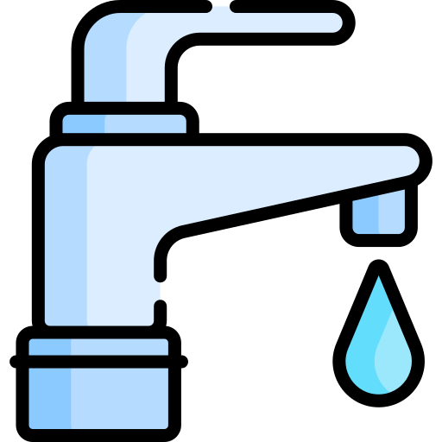 |  | 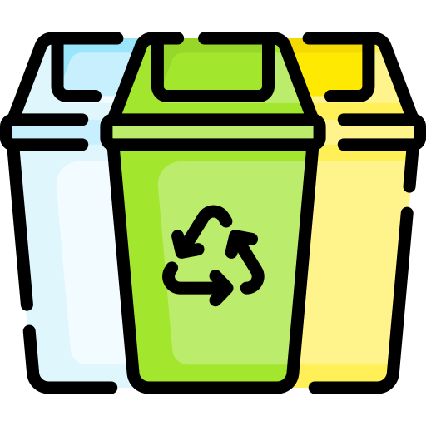 | 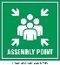 | 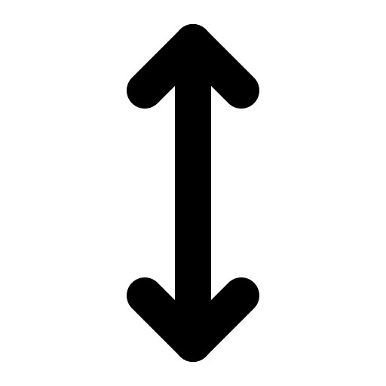 |  | 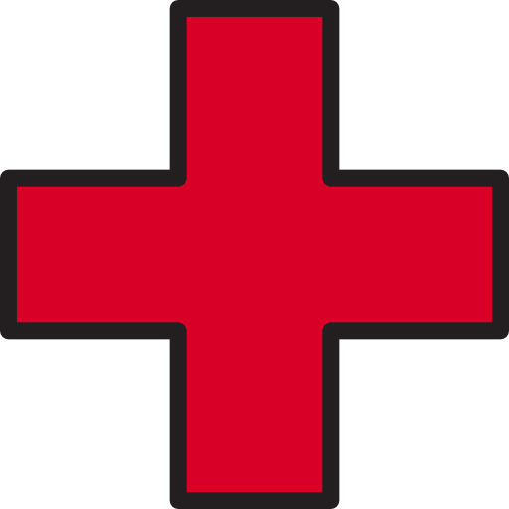 |  | 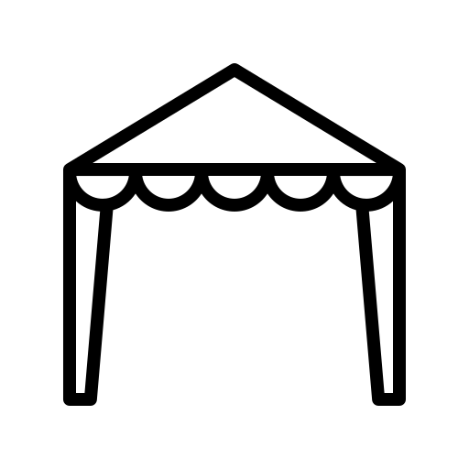 | 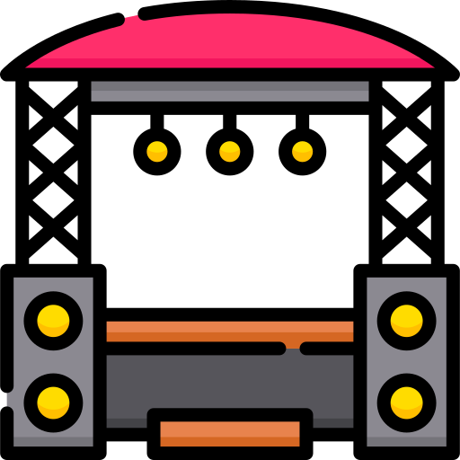 | 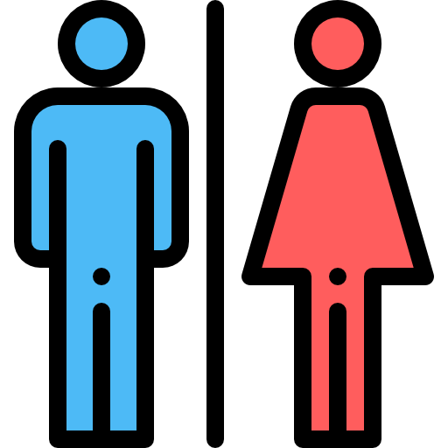 | 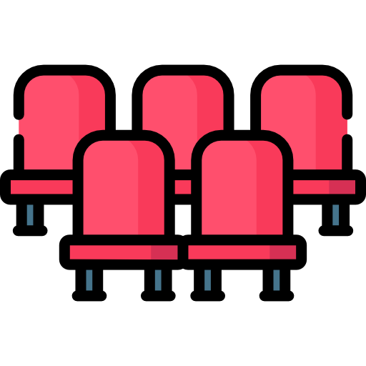
Drinking Water | Red Line Area  (Alcohol) | Bins | Evac  Area | Patron  Entry/  Exit | Emergency  Vehicle  Access | First  Aid | Info | Marquee  (Dimensions) | Stage  (Dimensions) | Toilets | Seating | Other  (Pick your own) | Other  (Pick your own)


INSERT GOOGLE IMAGE HERE (USE SNIPPING TOOL)

DRAG OR COPY ICONS ONTO MAP
(RIGHT CLICK, PRESS COPY, PRESS PASTE OR CRT C THEN CRT V)

SEE EXAMPLE ON NEXT PAGE

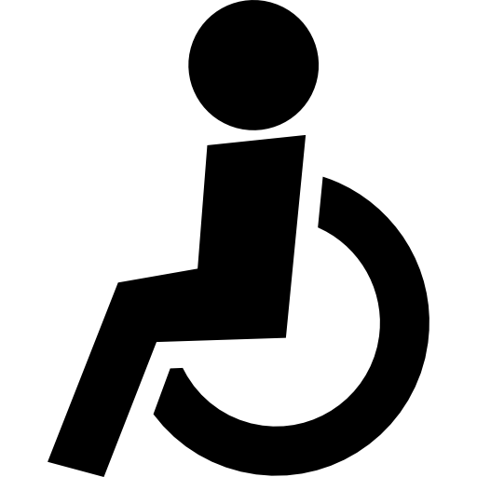 |  | 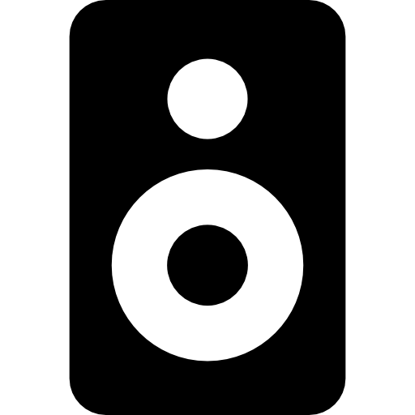 | 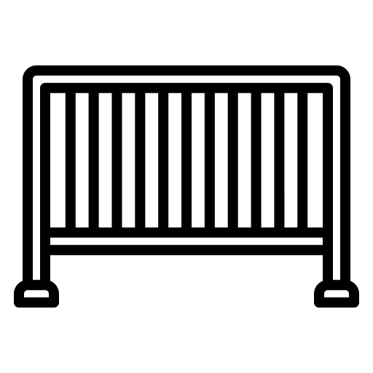 |  | 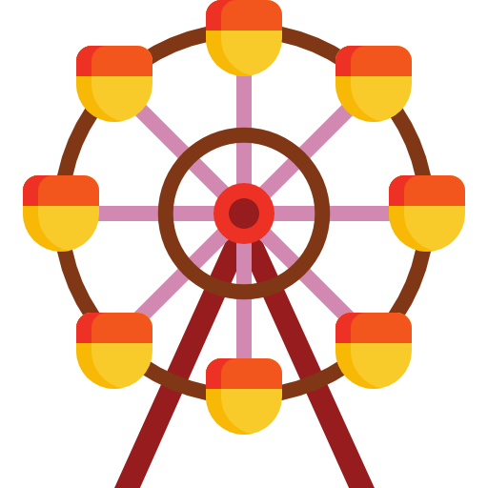 | 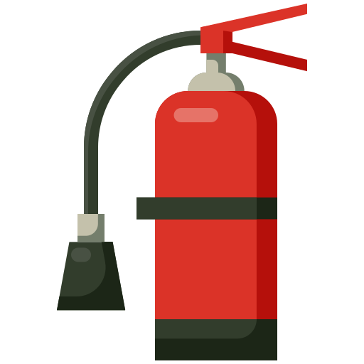 | 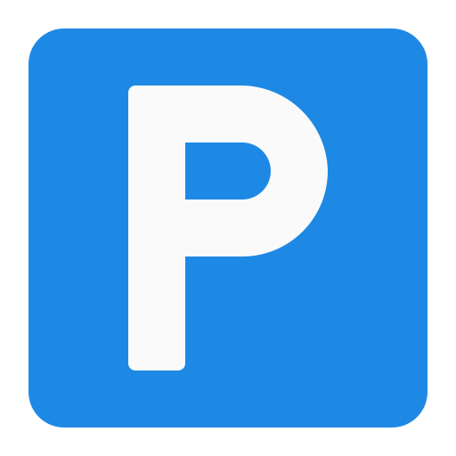 | 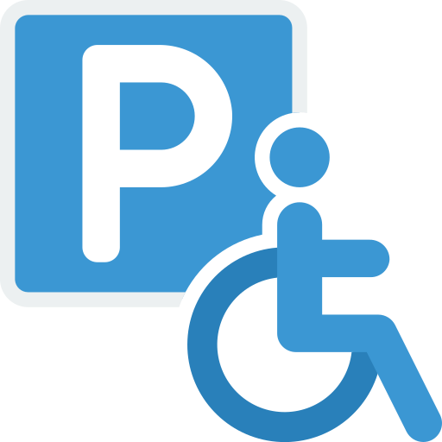 | 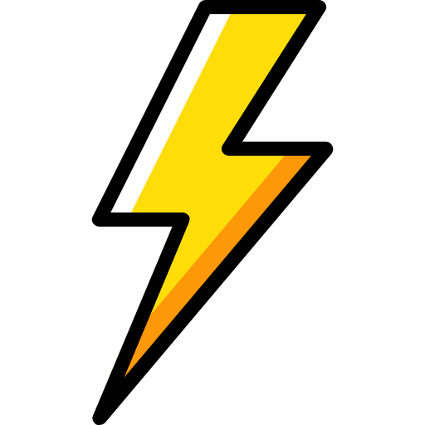
Accessible  View | Food/ Bev | PA | Crow Control Barrier | Temp Fencing | Amusements | Fire  Extinguisher | Car Parking | Accessible Parking | Power/ Generator | Other  (Pick your own) | Other  (Pick your own)

Drinking Water | Red Line Area  (Alcohol) | Bins | Evac  Area | Patron  Entry/  Exit | Emergency  Vehicle  Access | First  Aid | Info | Marquee  (Dimensions) | Stage  (Dimensions) | Toilets | Seating | Other  (Pick your own) | Other  (Pick your own)

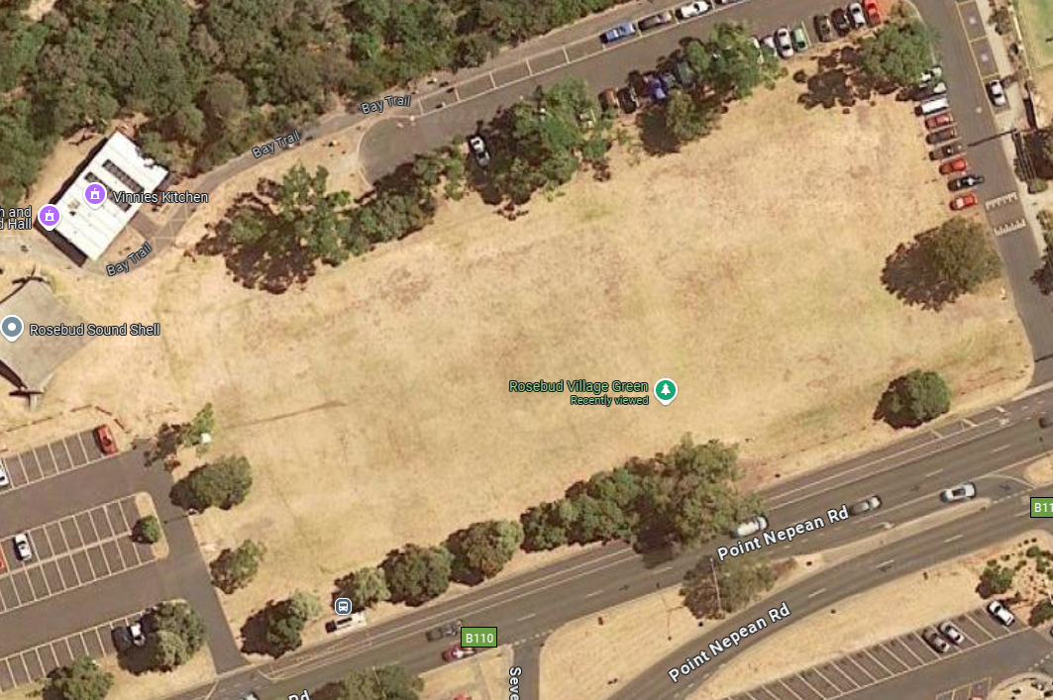

EXAMPLE ONLY

Accessible  View | Food/ Bev | PA | Crow Control Barrier | Temp Fencing | Amusements | Fire  Extinguisher | Car Parking | Accessible Parking | Power/ Generator | Other  (Pick your own) | Other  (Pick your own)

