<pp>1
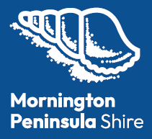

Council Plan
2025-29
<Transcriber's note> This document contains letters in coloured circles. These have been transcribed by enclosing the letters in parentheses, eg. (D). </Transcriber's note>
<pp>2

Acknowledgement of Country
Mornington Peninsula Shire acknowledges the Bunurong people, who have been the custodians of this land for many thousands of years; and pays respect to their Elders past and present. We acknowledge that the land on which we meet is the place of age-old ceremonies, celebrations, initiation and renewal; and that the Bunurong people's living culture continues to have a unique role in the life of this region.


<pp>3

Table of Contents
Mayor's Message
CEO's Message
Our Councillors
Our Wards
About the Mornington Peninsula
Our Values
Our Services
Strategic Overview
Our Community Vision
Plan Overview
Development of the Plan
How to read the Plan
Council's Role
Our Strategic Directions
Place
People
Prosperity
Performance
Reporting our Progress
Performance Measures
Plan on a page

<pp>4

Mayor's Message
I'm proud to present our Council Plan 2025–29, a forward-looking roadmap shaped by thousands of voices across our community. This is a plan that reflects your priorities, sets a clear direction for the next four years, and holds Council to account for delivering meaningful, measurable outcomes.
You told us you want better roads and infrastructure, more transparent and effective Council operations, and meaningful action to protect our natural environment and coastline. You also said fairness matters in how resources are allocated and how decisions are made. We've listened, and this plan reflects that feedback at every level.
We also heard how much you value the Peninsula's unique township and village character. This plan supports sensible growth while protecting the qualities that make our region so special.
The Peninsula is growing and evolving. Over the past decade we've seen major shifts in how people live, work, and connect. Looking ahead, we know more change is coming, and with it, new challenges and opportunities. This plan ensures we are prepared, responsive, and focused on the things that matter most to you.
At its core, the Council Plan is about community and is firmly grounded in our shared Community Vision. Thank you to everyone who contributed to this important piece of work. We look forward to delivering on it with you.
Councillor Anthony Marsh,
Mayor
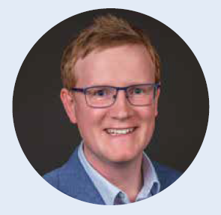
<pp>5

CEO's Message
As the new CEO of the Mornington Peninsula Shire, I'm thrilled that my appointment coincides with the delivery of this important plan. The Council Plan 2025-29 outlines our priorities and how we'll respond to the challenges and opportunities over the next four years.
This plan is the result of contributions from our community, Shire staff, Councillors and key stakeholders. I want to thank everyone who helped shape it. Your input—through forums, pop-ups, surveys and other engagements—has been vital in ensuring this plan reflects the needs and aspirations of our community.
This plan aligns with other important documents, including our shared Community Vision, Public Health and Wellbeing Plan, Financial Plan and Asset Plan. Together, they create a clear path for the future of our organisation.
As you read through these plans, you'll see that they address what matters most to our community—things like infrastructure, services, and good governance. We've also made sure that we focus on efficiency, fairness, and sustainability, while managing public resources responsibly.
It's important to keep you informed of our progress in fulfilling this plan.
We will provide regular updates on our website, ensuring transparency and accountability.
I look forward to continuing our strong focus on community, delivering great customer service, and working with our team to bring our shared vision for this beautiful part of Victoria to life.
Mark Stoermer,
CEO
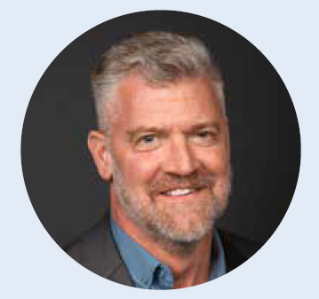
<pp>6

Our Councillors

Cr. Kate Roper
Beek Beek Ward
Cr. Max Patton
Benbenjie Ward
Cr. Anthony Marsh
Briars Ward

Cr. Patrick Binyon
Brokil Ward
Cr. David Gill
Coolart Ward
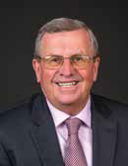
Cr. Stephen Batty
Kackeraboite Ward
Cr. Bruce Ranken
Moorooduc Ward
Cr. Andrea Allen
Nepean Ward
Cr. Paul Pingiaro
Tanti Ward
Cr. Cam Williams
Tootgarook Ward
Cr. Michael Stephens
Warringine Ward
For more information visit: mornpen.vic.gov.au/ourcouncillors
<pp>7

Our Wards
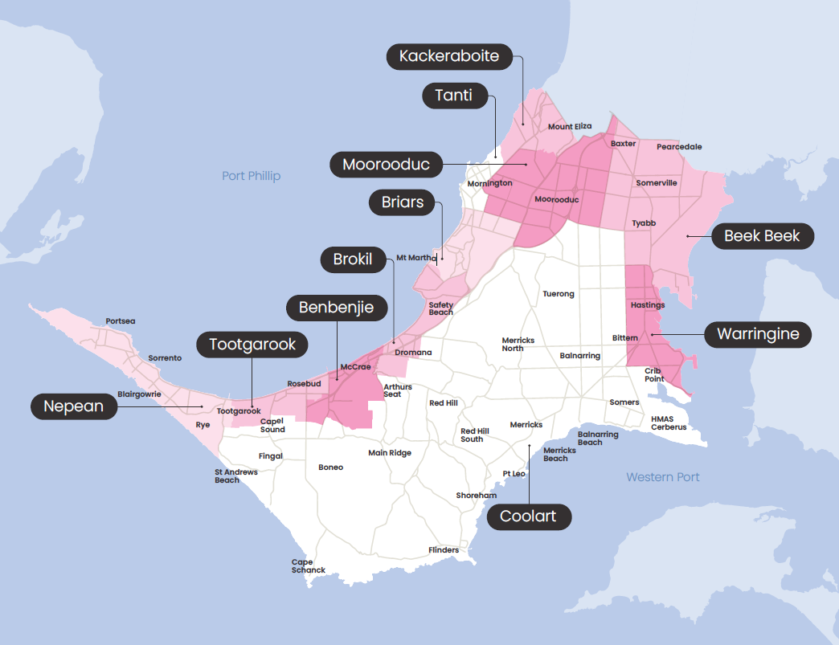
<Description>
This map displays the Mornington Peninsula Shire in Victoria, Australia, showing the municipality divided into wards. The shire is depicted in shades of pink and white against a light blue background representing Port Phillip Bay to the west and Western Port to the east.
The wards are labelled with dark rounded labels and include:
Northern Wards (pink)
- Nepean Ward – Sorrento, Portsea, Blairgowrie
- Tootgarook Ward – Rosebud and surroundings
- Benbenile Ward – Central-western region
- Briars Ward – Mt Martha area
- Brokil Ward – Northern section
- Moorooduc Ward – North-central area
- Tanti Ward – Northeastern area
- Kackeraboite Ward – Far northeast corner
- Beek Beek Ward – Eastern side
- Warringine Ward – Far eastern coast near Hastings
Southern Wards (white)
- Coolart Ward – Southern central region
</Description>
<pp>8

About the Mornington Peninsula
The Mornington Peninsula is located on the land of the Bunurong people. It sits on the fringe of Melbourne's outer southern suburbs and spans 723 square kilometres, with 192 kilometres of coastline along Port Phillip Bay, Western Port and Bass Strait. Around 70 per cent of the Peninsula is rural and Green Wedge, with the remaining 30 per cent made up of 40 townships and villages.
The region includes more than 1,735 kilometres of roads, 725 kilometres of footpaths, 342 kilometres of walking trails, and 106 kilometres of cycling trails. The Peninsula has a population of more than 175,000 people, with significant seasonal population increases due to tourism and holidaymakers. Townships span from Mount Eliza to Portsea, and from Baxter and Hastings to Crib Point and Balnarring. Larger population centres such as Mornington, Rosebud, Hastings and Sorrento are complemented by smaller communities such as Flinders, Merricks, Red Hill, Somers, Shoreham, St Andrews Beach and Tuerong.
The Peninsula is known for its distinct coastal villages, sandy beaches, lush parklands, vibrant arts scene and a proud First Nations history, which is reflected in Bunurong cultural heritage and significant sites.
Mornington Peninsula Shire is an 'interface Council'—a classification that recognises our community does not yet have full access to many services available in metropolitan Melbourne, often requiring residents to travel outside the municipality for key services.
<pp>9
- Population: 175,153
Expected to be 192,617 by 2046
- 51.7% female*
48.3% male*
Median age: 48
- 1% Aboriginal and/or Torres Strait Islander peoples
- 723km² of land
70% Green Wedge
- 192km of coastline
10% of Victoria's coast
- 1,735km of roads
- $11.3 billion in Gross Regional Product
- 62,311 jobs
- 17,072 businesses
All data presented in this plan is sourced from our website as of 2025: mornpen.vic.gov.au/ourpeninsula
*Please note: Other classifications of sex and gender were not released by local government area in the ABS Census 2021.
<pp>10

Our Values
The Mornington Peninsula Shire is committed to upholding the highest standards of performance, behaviour and service. To guide us in achieving exceptional outcomes for the community, we follow five core organisational values that are integral to everything we do.

Integrity
We take ownership and responsibility for our decisions; keep our promises; and hold each other accountable to the highest standards of performance.

Courage
We give honest advice; make tough calls with conviction; stand by our decisions; admit if we get it wrong; and challenge ourselves to explore new ways of thinking.

Openness
We share knowledge and learning for the benefit of all; actively engage with our community; and are transparent in our decision making.

Respect
We treat everyone with dignity, fairness and empathy; look out for our safety and wellbeing; and nurture positive and inclusive relationships.

Excellence
We provide exceptional customer service; strive for innovative team outcomes for the betterment of our community; and step up to lead where we recognise an opportunity for improvement.
<pp>11

Our Services
Mornington Peninsula Shire is primarily a service-based organisation. We deliver about 150 services (including both services delivered directly to the community and internal support services) in support of achieving our Community Vision. These are grouped into 40 high-level service areas, including the following 22 that directly engage with the community.
We aim to deliver high-quality services that balance community needs with strategic direction, innovation and long-term financial sustainability.

Liveable Communities
- Economic Development and Business Support
- Land Use Planning
- Open Space
- Transport Connections

Community Health and Safety
- Animal Management
- Building Safety
- Child and Family Health
- Community Safety
- Emergency Management
- Public Health
- Public Works

Community Wellbeing and Connection
- Arts and Cultural Development
- Community Development
- Community Services
- Early Years
- Libraries
- Positive Ageing
- Recreation and Leisure
- Youth Services

Sustainable Environment
- Circular Economy and Waste Management
- Climate Action and Advocacy
- Environment Management
<pp>12

Strategic Overview
Under the Local Government Act 2020, Councils are required to:
- Align all strategic planning with the Community Vision.
- Use an integrated approach to planning, monitoring and performance reporting.
To meet these requirements, we use the Integrated Strategic Planning and Reporting Framework. This helps us to stay focused on achieving our shared Community Vision and ensures we regularly monitor our progress and report back to the community.
Our Council Plan outlines the strategic objectives and strategies we will put in place to achieve our Community Vision. It's supported by targeted strategies and plans focused on specific areas.
Each year, alongside the budget, we prepare an Annual Action Plan that outlines the key actions we will deliver under the Council Plan.
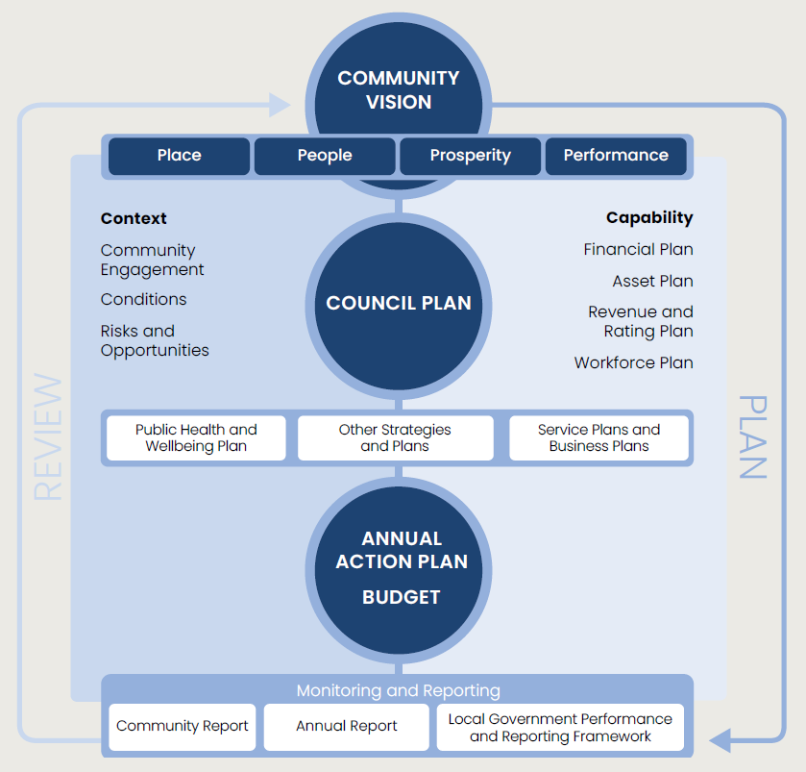
<Description>
This diagram presents a hierarchical flow chart showing how strategic planning operates within the Mornington Peninsula Shire, from community vision through to implementation and reporting.
At the top of the diagram is a dark blue circle containing "Community Vision," which sits above four navy rectangular tabs labelled "Place," "People," "Prosperity," and "Performance."
Below this, the framework is divided into left and right sections. On the left under "Context" are listed: Community Engagement, Conditions, and Risks and Opportunities. On the right under "Capability" are listed: Financial Plan, Asset Plan, Revenue and Rating Plan, and Workforce Plan.
In the centre is a large dark blue circle containing "Council Plan," which serves as the central strategic document.
Beneath the Council Plan are three white rectangular boxes containing: "Public Health and Wellbeing Plan," "Other Strategies and Plans," and "Service Plans and Business Plans."
Further down is another dark blue circle containing "Annual Action Plan Budget."
At the bottom of the diagram under "Monitoring and Reporting" are three white boxes: "Community Report," "Annual Report," and "Local Government Performance and Reporting Framework."
Blue arrows on the right side indicate a cyclical relationship, showing that reporting feeds back into the planning process.
</Description>
<pp>13

Our Community Vision
Welcome (Wominjeka).
We celebrate, protect and enhance our unique blend of coast, hinterland, Green Wedge and heritage – fostering our diverse culture and connected villages, townships and community.
We are committed to supporting community groups, sustainable and balanced growth, a vibrant local economy, fit-for-purpose infrastructure, and ensuring a prosperous, safe, accessible and inclusive future for all.
Our Community Vision can be themed into the following groupings, forming Council's strategic direction.

Place
Celebrate, protect and enhance our unique blend of coast, hinterland, Green Wedge and connected villages and townships.

People
A safe, accessible, inclusive and engaged community that fosters our diverse culture, supporting health and wellbeing and a connected and compassionate society for all.

Prosperity
Enabling balanced growth through innovation, empowering community groups and volunteers, and fostering a resilient, thriving and vibrant local economy.

Performance
A transparent, accountable council delivering measurable, community-centred services that are cost-effective, fit-for-purpose, future-proofed and responsive to community needs.
<pp>14

Plan Overview

Development of the Plan
We developed this Plan with the help of more than 3,000 community members who shared their ideas, concerns and priorities with us in early 2025.
These conversations took place as part of a two-month community engagement process that also helped shape the Public Health and Wellbeing Plan, Financial Plan and Asset Plan. We used a mix of broad and deliberative engagement methods to better understand the challenges our community faces and the opportunities we can work on together.
Council is committed to involving the Mornington Peninsula community, wherever possible, in decisions that affect them. This engagement was a testament to that commitment, bringing together valuable community insights to guide our planning for the future.

How we engaged
We connected with people in a range of ways to ensure a broad and diverse mix of voices were heard:
- 1,569 responses to our online survey, including from:
  - 890 people over the age of 60
  - 245 people that have disability
  - 22 people that identify as Aboriginal and/or Torres Strait Islander
  - 30 people that identify as LGBTIQA+
  - 95 people that speak a language other than English at home
- 930 conversations at our 18 pop-up locations.
- 262 postcards completed by primary school aged children.
- 44 children took part in kindergarten group activities.
- 70 responses to our youth survey (12-17 years).
- 3 in person Community Conversations as part of our deliberative engagement.
We heard from people across all ages, genders, backgrounds and abilities—reflecting the diversity of the Mornington Peninsula.
The draft Council Plan was presented for public exhibition for a 6-week period, with a further 385 responses helping to shape the final plan.

What we heard
Community members told us their top priorities are:
- Better management of Shire roads and infrastructure.
- Improvements to how Council operates.
- Protecting our natural environment and the Green Wedge.
- Ongoing management of waste services.
- Better transport options including paths and trails.
You can read more about what we heard in the Community Engagement Findings Report at: mornpen.vic.gov.au/councilplan

Equity Impact Assessments
In line with the Gender Equality Act 2020, we undertook Equity Impact Assessments (including Gender Impact Assessments) on our Community Vision and community engagement approach, as well as the draft Council Plan and Public Health and Wellbeing Plan. These assessments evaluated how the Plans may affect our community based on their gender (women, men and gender-diverse people) as well as other attributes such as age, cultural background, disability, and sexual and gender identities. This process ensures the Plans are inclusive and equitable, address potential negative impacts, and meet Council's various legislative obligation including those under the Gender Equality Act 2020 (Vic), the Public Health and Wellbeing Act 2008 (Vic), the Disability Act 2006 (Vic) and the Disability Discrimination Act 1992 (Cth).
<pp>15

How to read the Plan
The Council Plan consists of the following parts:
- Strategic direction: Council's priority areas. These are aligned with the Community Vision themes.
- Strategic objectives: The outcomes Council is seeking to achieve to support the strategic direction.
- Strategic indicators: How we measure progress towards our strategic objectives (reported annually through our Annual Report).
- Strategies: What we prioritise and do to achieve our objectives.
- Supporting documents: The key strategic plans and policies of Council that support delivery of our priorities.
- Performance measures: How we measure our performance in delivering our strategies and priorities (reported quarterly through our Community Report).

Council's Role
Council plays a number of different roles in supporting the community. Council's role in delivering the strategies in this plan is represented as follows:
(D) Deliver: Plan and deliver evidence-based programs, services, and policies, undertake community and stakeholder engagement as well as provide and maintain facilities and infrastructure.
(P) Partner: Work collaboratively with and build the capability of key stakeholders, community groups and individuals to provide and support evidence-informed programs, services and policies.
(A) Advocate: Advocate for systemic change and increased resourcing to address challenges and improve the local service sector.
(R) Regulate: Fulfil legislative requirements and ensure effective use of public resources, such as compliance with health standards, enforcement of local laws and management of community infrastructure.
<pp>16

Our Strategic Directions

Place
Strategic Direction 1
<pp>17
Celebrate, protect and enhance our unique blend of coast, hinterland, Green Wedge and connected villages and townships.
Fast Facts:
- Home to an internationally significant biosphere reserve and state significant wetlands
- 400 species of native animals
- 1/5th of the state's flora
- 37 per cent tree canopy coverage in urban areas
- 440km of waterways
- 40 townships and villages
- 93,600 dwellings across the Peninsula
- 82 per cent of the Peninsula is not serviced by public transport
<pp>18

Strategic Objective 1.1:
Protected, resilient and enhanced natural environments.
Council's Role: (D) Deliver, (P) Partner, (A) Advocate, (R) Regulate
Strategies:
- Engage the community to protect and improve natural landscapes, ecosystems and biodiversity. (D) (P)
- Manage our beaches and foreshores to ensure they are safe, accessible, enjoyable and resilient to the impacts of coastal change. (D) (P)
- Maintain and enhance our public open spaces. (D) (P)
- Support the ongoing protection of the Green Wedge to maintain its environmental, agricultural, recreational and tourism value. (D) (A) (R)
- Build our environmental resilience to climate change through adaptation and mitigation. (D) (P) (A)
- Effectively manage water by building flood resilience, preserving waterways, advocating for safe supply and supporting wastewater and recycled systems. (D) (P) (A) (R)
- Promote and work towards a zero waste circular economy to preserve our environment and strengthen the local economy. (D) (P) (A)
Supporting documents:
- Beyond Zero Waste Strategy
- Biodiversity Conservation Plan
- Green Wedge Management Plan
- Open Space Strategy
- Our Coast Our Future: Coastal Strategy
- Our Water Future: Integrated Water Management Plan
- Urban Forest Strategy
Strategic indicators:
Indicator | Target
Total area of wildlife habitat | Increase ↑
Tree canopy coverage in urban areas | 45% (by 2034) ↑
Proportion of people who are satisfied with our beaches and foreshore areas | Increase ↑
Proportion of people who use public open space on a regular basis | Increase ↑
Total area of Green Wedge | Maintain ✓
Kerbside collection waste diverted from landfill | Increase ↑
Publicly available and updated flood mapping information | Annual targets met ✓
Greenhouse gas emissions | Decrease ↓
<pp>19

Strategic Objective 1.2:
Connected townships with integrated and accessible transport and well-maintained infrastructure.
Council's Role: (D) Deliver, (P) Partner, (A) Advocate, (R) Regulate
Strategies:
- Plan and regulate responsible development to accommodate future growth while maintaining neighbourhood character. (D) (A) (R)
- Manage and maintain accessible facilities and assets that meet community needs. (D) (P)
- Create an integrated and safe transport network and advocate for improved transport options. (D) (P) (A)
- Improve the quality of our roads. (D)
- Enhance and expand recreation trails across the Peninsula. (D) (P) (A)
Supporting documents:
- Asset Plan
- Community Facility Infrastructure Strategy
- Housing and Settlement Strategy
- Integrated Transport Strategy
- Neighbourhood Character Study
- Pedestrian Access Strategy
- Peninsula Trail Strategic Plan
- Property Strategy
- Public Amenity Strategy
- Road Improvement Strategy
- Road Management Plan
- Road Safety Strategy
- Universal Design Policy
Strategic indicators:
Indicator | Target
Available housing land supply | Plan Victoria targets met ✓
Usage of community buildings and facilities | Increase ↑
People who travel by active transport to work | Increase ↑
People satisfied with the condition of the Shire's public areas | Increase ↑
People satisfied with the condition of the Shire's roads | Increase ↑
Shire roads assessed to be in a poor condition | Decrease ↓
Asset renewal gap | Asset Plan targets met ✓
<pp>20

People
Strategic Direction 2
<pp>21
A safe, accessible, inclusive and engaged community that fosters our diverse culture, supporting health and wellbeing and a connected and compassionate society for all.
Fast Facts:
- Our median age of 48 is 11 years older than the Australian average
- 81 per cent of people report excellent, very good or good health
- 1 per cent of people identify as Aboriginal and/or Torres Strait Islander
- 3rd largest Aboriginal and Torres Strait Islander population in the Southern Metropolitan area
- 6 townships suffering rental stress (higher than the Australian average)
- An estimated 948 community members sought assistance for homelessness in 2024-25, an increase of 16 per cent from the previous year.
- 5.4 per cent of people identify as LGBTIQA+
- 23 per cent of people have disability
<pp>22

Strategic Objective 2.1: A safe, accessible, inclusive and healthy community.
Council's Role: (D) Deliver, (P) Partner, (A) Advocate, (R) Regulate
Strategies:
- Actively promote and improve the health and wellbeing of all community members. (D) (P) (A)
- Support people of all ages, genders, identities and abilities through equitable, inclusive and universally-designed services, supports and infrastructure. (D) (P)
- Build respectful relationships and create meaningful opportunities with Aboriginal and Torres Strait Islander peoples. (D) (P)
- Promote community safety through prevention, education and regulation. (D) (A) (P) (R)
- Work in partnership with stakeholders to advocate for appropriate, available and affordable housing. (P) (A)
- Promote and support initiatives that strengthen community resilience and adaptation to emergencies and climate impacts. (P) (A)
Supporting documents:
- Community Disaster Resilience Strategy
- Domestic Animal Management Plan
- Gender Equality Strategy
- Municipal Emergency Management Plan
- Public Health and Wellbeing Plan
- Reconciliation Action Plan
- Triple A Housing Plan
- Universal Design Policy
- We All Belong Strategy
Strategic indicators:
Indicator | Target
Proportion of people who self-rate their health as good or very | Increase ↑
Proportion of people who feel valued by society | Increase ↑
Proportion of people who have access to services and supports that meet their needs | Increase ↑
Proportion of people who feel safe in the community | Increase ↑
<pp>23

Strategic Objective 2.2:
An engaged and connected community.
Council's Role: (D) Deliver, (P) Partner, (A) Advocate, (R) Regulate
Strategies:
- Improve and promote social connection within our community. (D) (P)
- Provide inclusive and accessible recreation and leisure opportunities across the Peninsula. (D) (P) (A)
- Encourage and support a rich, inclusive and vibrant arts and culture community. (D) (P) (A)
- Encourage and support skills development and lifelong learning opportunities. (D) (P)
- Communicate proactively and transparently with our community to enhance engagement and collaboration. (D) (P)
Supporting documents:
- Arts, Culture and Events Plan
- Community Engagement Strategy
- Music Plan
- Our Library Strategy
- Pavilion Strategy
- Playspace Strategy
- Recreational Facilities for Mountain Bike and BMX Strategy
- Sports Capacity Plan
- Sports Fair Access Plan
Strategic indicators:
Indicator | Target
Proportion of people that feel connected to the community | Increase ↑
Proportion of people that belong to an organised group | Increase ↑
Community participation in Council's engagement activities | Increase ↑
<pp>24

Prosperity
Strategic Direction 3
<pp>25
Enabling balanced growth through innovation, empowering community groups and volunteers, and fostering a resilient, thriving and vibrant local economy.
Fast Facts:
- 55 per cent of workers live and work on the Peninsula
- 74 per cent of 15–24-year-olds are fully engaged in work or study
- Top 5 industries: health care, construction, retail, accommodation and food services, education and training
- 7.9 million visitors to our region in 2024
- Estimated worth of our agriculture and food industry is $1.3 billion (second highest in Victoria)
- 32,250 hours contributed by Shire volunteers each year
<pp>26

Strategic Objective 3.1:
A vibrant, innovative and thriving local economy.
Council's Role: (D) Deliver, (P) Partner, (A) Advocate, (R) Regulate
Strategies:
- Engage with local businesses and industry to attract investment, innovation and economic growth. (D) (P) (R)
- Support and advocate for inclusive education, employment and training pathways for our community. (P) (A)
- Promote the Peninsula as a premier cultural and tourism destination, attracting local, national and global visitors and events. (P) (A)
- Advocate for sufficient commercial and industrial land on the Peninsula to meet future needs. (P) (A)
- Foster a strong and sustainable farming, food and beverage economy. (P) (A)
Supporting documents:
- A Thriving Peninsula: Economic Development and Tourism Strategy
- Activity Centres Strategy
- Arts, Culture and Events Plan
- Food Economy and Agroecology Strategy
- Industrial Areas Strategy
- Industrial Land Use and Infrastructure Assessment and Rezoning Strategy
- We All Belong Strategy
Strategic indicators:
Indicator | Target
Gross regional product | Increase ↑
Total number of jobs | Increase ↑
Proportion of employed people who reside and work on the Peninsula | Increase ↑
Total number of visitors to the Peninsula | Increase ↑
Available industrial land supply | Increase ↑
Economic output of the Agrifood Industry | Increase ↑
<pp>27

Strategic Objective 3.2:
Valued partnerships and empowered community groups and volunteers.
Council's Role: (D) Deliver, (P) Partner, (A) Advocate, (R) Regulate
Strategies:
- Develop and invest in local community groups and organisations to build community capacity. (D) (P)
- Coordinate, promote and celebrate volunteer-supported services and programs that encourage and enable volunteering. (D) (P)
- Seek and enable increased external investment in community assets and services, including community and private investment. (P)
- Explore, foster and strengthen strategic partnerships with all levels of government, service providers and key stakeholders to generate positive outcomes for the Peninsula. (P) (A)
- Encourage our community to drive our key advocacy priorities. (P) (A)
Supporting documents:
- A Thriving Peninsula: Economic Development and Tourism Strategy
- Community Capital Infrastructure Policy
- Community Investment Funding Policy
- Volunteer Management Policy
- We All Belong Strategy
Strategic indicators:
Indicator | Target
Return on investment from community investment funding | Increase ↑
Proportion of people who volunteer in the community | Increase ↑
Estimated volunteer hours and financial value of community volunteers | Increase ↑
Proportion of volunteer participants who feel their community contribution was valued | Increase ↑
Total external investment in community assets and services | Increase ↑
Community participation in advocacy projects | Increase ↑
<pp>28

Performance
Strategic Direction 4
<pp>29
A transparent, accountable Council delivering measurable, community-centred services that are cost-effective, fit-for-purpose, future-proofed, and responsive to community needs.
Fast Facts:
- 140,000 customer service calls a year
- 30,000 customer service centre visits a year
- Overall community satisfaction of 6.5
- Average rate per property of $1,653
<pp>30

Strategic Objective 4.1:
A financially sustainable, high-performing and well-governed Council.
Council's Role: (D) Deliver, (P) Partner, (A) Advocate, (R) Regulate
Strategies:
- Provide long-term financial sustainability through operational efficiencies and increased revenue opportunities. (D)
- Practice good governance, ensuring decisions are informed, made in accordance with relevant laws and benefit the community. (D)
- Implement an integrated framework for planning, monitoring and reporting that enhances transparency and delivery of community outcomes. (D)
- Ensure a safe and inclusive workforce that has the right capacity, capability and culture to deliver our strategic direction. (D)
- Maximise technology systems, processes and data to improve service delivery, increase efficiency and enhance decision making. (D)
Supporting documents:
- Cybersecurity Strategy
- Data Governance Framework
- Financial Plan
- Governance Framework
- Integrated Strategic Planning and Reporting Framework
- IT and Digital Strategy
- Project Management Framework
- Revenue and Rating Plan
- Workforce Plan
Strategic indicators:
Indicator | Target
Overall community satisfaction with Council | Increase ↑
Community satisfaction with governance and decision making | Increase ↑
Balanced budget forecast over the short, medium and long-term | Financial Plan targets met ✓
Annual budget variance | <±10% ✓
Overall achievement of Council Plan | >70% of strategic indicators achieved ✓
Organisational full time equivalent staff numbers | Financial Plan targets met ✓
<pp>31

Strategic Objective 4.2:
Community-centred, responsive, and fit-for-purpose services.
Council's Role: (D) Deliver, (P) Partner, (A) Advocate, (R) Regulate
Strategies:
- Plan, deliver and review our services to ensure they are inclusive, benefit our community and meet current and future needs. (D)
- Make our customer interactions easy, consistent and responsive. (D)
- Foster a community-centred and continuous improvement approach across Council. (D)
Supporting documents:
- Benefits Management Framework
- Customer Charter
- Our Customer Strategy
- Service Management Framework
Strategic indicators:
Indicator | Target
Community satisfaction with customer service | Increase ↑
Community satisfaction with Shire services | Increase ↑
Level 1 services reviewed | All services reviewed within past 5 years ✓
Benefits realised from service reviews | Service reviews targets met ✓
<pp>32

Reporting our Progress
Each financial year, alongside the budget, we develop Annual Action Plans that outline the key actions Council will deliver in each financial year in support of the strategies identified in this Plan.
We report our progress against the Annual Action Plan on a quarterly basis as part of our Community Report. To learn more, visit:
mornpen.vic.gov.au/communityreports
Performance measures sit below our strategic indicators, for each of our strategic objectives, enabling us to measure our progress every quarter.
The performance measures are provided in the table on the following pages.
We also report progress against each of our strategies and strategic indicators through our Annual Report.
<pp>33

Performance Measures

Strategic Objective 1.1: Protected, resilient and enhanced natural environments.
Measure | Target | Frequency
Area of bushland management works completed | Target set annually | Annually
Number of bushland working bees supported | Target set annually | Quarterly
Number of trees planted | Target set annually | Annually
Total length of beaches cleaned | Target set annually | Quarterly
Number of drainage pits inspected and cleaned | Target set annually | Quarterly
Tonnes of kerbside waste diverted from landfill | Increase | Quarterly

Strategic Objective 1.2: Connected townships with integrated and accessible transport and well-maintained infrastructure.
Measure | Target | Frequency
Average time for planning applications | Decrease | Quarterly
Planning applications decided within required timeframes | >60% | Quarterly
Compliance with our Road Management Plan (RMP) | RMP targets met | Annually
Total area of roads resurfaced and/or rehabilitated | Target set annually | Annually
Grant funding secured for roads | Not applicable | Annually
Percentage of compliance metrics from maintenance service contracts met | Targets in contracts met | Quarterly
Capital works renewal expenditure | Asset Plan targets met | Annually
<pp>34

Strategic Objective 2.1: A safe, accessible, inclusive and healthy community.
Measure | Target | Frequency
Number of preventative health and wellbeing initiatives delivered | Target set annually | Annually
Number of equity impact assessments undertaken on services, programs and policies | Increase | Quarterly
Number of compliance investigations completed within statutory timeframes | Increase | Quarterly
Participation in Maternal Child Health Care services | State targets met | Quarterly
Kindergarten participation rate | >95% | Annually
Youth participation in Council-provided programs | Increase | Annually
Delivery of Reconciliation Action Plan actions and targets | Target set annually | Annually
Delivery of initiatives from We All Belong Strategy | Target set annually | Annually

Strategic Objective 2.2: An engaged and connected community.
Measure | Target | Frequency
Number of programs delivered via Community Houses | Increase | Quarterly
Number of community-led events and projects, supported by Council, that promote social connection | Increase | Quarterly
Participation in Library programs | Increase | Quarterly
Number of recreation and leisure groups meeting diversity and access requirements | Increase | Annually
Participation in arts and culture activities | Increase | Annually
Number of engagement projects open each quarter | Not applicable | Quarterly
Total number of followers and subscribers across communication mediums | Increase | Quarterly
<pp>35

Strategic Objective 3.1: A vibrant, innovative and thriving local economy.
Measure | Target | Frequency
Average timeframe for business applications | Decrease | Quarterly
Number of business events and workshops led or supported | Target set annually | Quarterly
Number of community events held or supported | Increase | Quarterly
Average timeframe for event applications | Decrease | Quarterly
Visitations to Shire destinations | Increase | Quarterly

Strategic Objective 3.2: Valued partnerships and empowered community groups and volunteers.
Measure | Target | Frequency
Funding provided through Community Investment Funding | 90-100% of adopted CIF budget | Quarterly
Number of advocacy campaigns delivered | Target set annually | Annually
Approval timeframes for community capital projects | Decrease | Quarterly
Total number of Shire volunteers | Increase | Quarterly
<pp>36

Strategic Objective 4.1: A financially sustainable, high-performing and well-governed Council.
Measure | Target | Frequency
Net Operating Expenses | <100% of adopted forecast | Quarterly
Expenditure on capital works projects | >90% of adopted forecast | Quarterly
Annual Action Plan actions completed or on track | >80% | Quarterly
Council decisions made at meetings closed to the public | <10% | Quarterly
Freedom of information requests resolved within statutory timeframes | >95% | Quarterly
Voluntary staff turnover | Target set annually | Quarterly
Time taken to fill positions | Not applicable | Quarterly
Staff engagement | >60% | Biennially
Audited contractor compliance to contract management plans | >90% | Annually
Number of negative contract variations | Decrease | Quarterly

Strategic Objective 4.2: Community-centred, responsive, and fit-for-purpose services.
Measure | Target | Frequency
Customer requests actioned within timeframe | 80% | Quarterly
Average time for customer requests | Decrease | Quarterly
Voice of customer satisfaction score | Increase | Quarterly
First contact resolution | Target set annually | Quarterly
Total number of customer interactions across all channels (in person, phone, webchat and web page visits) | Not applicable | Quarterly
<pp>37-38

Plan on a page

Place

1.1 Protected, resilient and enhanced natural environments.
- Engage the community to protect and improve natural landscapes, ecosystems and biodiversity.
- Manage our beaches and foreshores to ensure they are safe, accessible, enjoyable and resilient to the impacts of coastal change.
- Maintain and enhance our public open spaces.
- Support the ongoing protection of the Green Wedge to maintain its environmental, agricultural, recreational and tourism value.
- Build our environmental resilience to climate change through adaptation and mitigation.
- Effectively manage water by building flood resilience, preserving waterways, advocating for safe supply and supporting wastewater and recycled systems.
- Promote and work towards a zero waste circular economy to preserve our environment and strengthen the local economy.

1.2 Connected townships with integrated and accessible transport and well-maintained infrastructure.
- Plan and regulate responsible development to accommodate future growth while maintaining neighbourhood character.
- Manage and maintain accessible facilities and assets that meet community needs.
- Create an integrated and safe transport network and advocate for improved transport options.
- Improve the quality of our roads.
- Enhance and expand recreation trails across the Peninsula

People

2.1 A safe, accessible, inclusive and healthy community.
- Actively promote and improve the health and wellbeing of all community members.
- Support people of all ages, genders, identities and abilities through equitable, inclusive and universally designed services, supports and infrastructure.
- Build respectful relationships and create meaningful opportunities with Aboriginal and Torres Strait Islander peoples.
- Promote community safety through prevention, education and regulation.
- Work in partnership with stakeholders to advocate for appropriate, available and affordable housing.
- Promote and support initiatives that strengthen community resilience and adaptation to emergencies and climate impacts.

2.2 An engaged and connected community.
- Improve and promote social connection within our community.
- Provide inclusive and accessible recreation and leisure opportunities across the Peninsula.
- Encourage and support a rich, inclusive and vibrant arts and culture community.
- Encourage and support skills development and lifelong learning opportunities.
- Communicate proactively and transparently with our community to enhance engagement and collaboration.

How will we achieve this?
Each year, alongside the budget, we prepare an Annual Action Plan, which sets out the key actions we will deliver under the Council Plan.

<pp>39

Our Community Vision
Welcome (Wominjeka).
We celebrate, protect and enhance our unique blend of coast, hinterland, Green Wedge and heritage – fostering our diverse culture and connected villages, townships and community.
We are committed to supporting community groups, sustainable and balanced growth, a vibrant local economy, fit-for-purpose infrastructure, and ensuring a prosperous, safe, accessible, and inclusive future for all.

Prosperity

3.1 A vibrant, innovative and thriving local economy.
- Engage with local businesses and industry to attract investment, innovation and economic growth.
- Support and advocate for inclusive education, employment and training pathways for our community.
- Promote the Peninsula as a premier tourism destination, attracting local, national and global visitors and events.
- Advocate for sufficient commercial and industrial land on the Peninsula to meet future needs.
- Foster a strong and sustainable farming, food and beverage economy.

3.2 Valued partnerships and empowered community groups and volunteers.
- Develop and invest in local community groups and organisations to build community capacity.
- Coordinate, promote and celebrate volunteer supported services and programs that encourage and enable volunteering.
- Seek and enable increased external investment in community assets and services, including community and private investment.
- Explore, foster and strengthen strategic partnerships with other levels of government, service providers and key stakeholders to generate positive outcomes for the Peninsula.
- Encourage our community to drive our key advocacy priorities.

Performance

4.1 A financially sustainable, high-performing and well-governed Council.
- Provide long-term financial sustainability through operational efficiencies and increased revenue opportunities.
- Practice good governance, ensuring decisions are informed, made in accordance with relevant laws and benefit the community.
- Implement an integrated framework for planning, monitoring and reporting that enhances transparency and delivery of community outcomes.
- Ensure a safe and inclusive workforce that has the right capacity, capability and culture to deliver our strategic direction.
- Maximise technology systems, processes and data to improve service delivery, increase efficiency and enhance decision making.

4.2 Community-centred, responsive, and fit-for-purpose services.
- Plan, deliver and review our services to ensure they are inclusive, benefit our community and meet current and future needs.
- Make our customer interactions easy, consistent and responsive.
- Foster a community-centred and continuous improvement approach across Council.

How will we measure progress?
Each quarter we prepare a Community Report to report progress against our annual actions and the performance measures in the Council Plan.
Each year we prepare an Annual Report to report progress against our objectives and strategic indicators in the Council Plan
Want to know more visit: mornpen.vic.gov.au/councilplan
<pp>40

Contact Mornington Peninsula Shire
Phone: 1300 850 600 (24 hours)
TTY: 133 677 then request 1300 850 600
TIS: 131 450
NRS: Connect to NRS on accesshub.gov.au then request 1300 850 600
Email: customerservice@mornpen.vic.gov.au
Mail: Private Bag 1000, Rosebud, Victoria, 3939
Website: mornpen.vic.gov.au
facebook.com/mornpenshire
instagram.com/ourpeninsula
youtube.com/MornPenShire

Mornington Peninsula Shire Service Centres
Rosebud Office
90 Besgrove Street, Rosebud
Mornington Office
2 Queen Street, Mornington
Hastings Office
21 Marine Parade, Hastings

